**First Prototype Test Plan**

Speech Interactive Therapy App



Team 13

Speech Therapy

Team Members

Jenni Norell: janorell@bu.edu

Diana DeLeon: ddel@bu.edu

Zhe Deng: thezhe@bu.edu

Swathi Jaisankar: swathij@bu.edu

Cindhuja Sramasamy: cindhu25@bu.edu

Equipment/Setup:

* Hardware:
  + A Windows Laptop with a Microphone
* Software:
  + Unity 3D Editor

Pre-Test Setup Procedure:

Be sure to have a windows computer with Unity3D installed

Testing Procedure:

1. Run project on Unity (start at levels menu)
2. Demonstrate ability to go to parent’s corner demonstrating that Math Check works
3. Go into a level and play video
4. Demonstrate vocal recognition aspect
5. Demonstrate reward response
6. Exit level and return to levels menu
   1. Demonstrate math check
7. Return to home page

Measurable Criteria:

* Framerate metadata
  + Test with FRAPS on a windows build
  + 1% lows should be above 60 fps
  + Test with many rewards triggers
* Scene Transitions and avg time to transition
  + Debug Log should print time to transition between scenes
  + Transitions should be a few milliseconds at most
  + Transitions follow state diagram and no deadlocks

[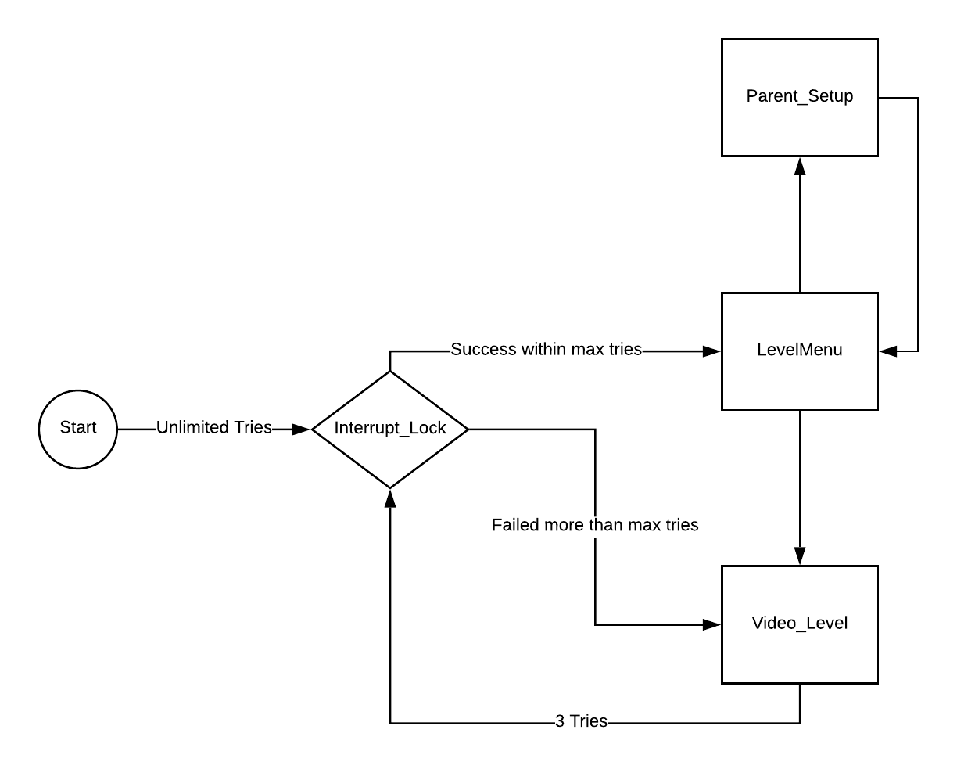](https://www.lucidchart.com/documents/edit/0cce8c1b-820b-4a06-8b9c-1a4662e974e1/0?callback=close&name=docs&callback_type=back&v=396&s=612)

Notes:

* Video Level should play rewards after 3 loops
* After failing more than max tries, Video level locks for 60 seconds
* All transitions should not be noticable, although Video_Level may need a loading screen in the future due to loading large video and audio assets
* Video Level is the only scene in which the child should ever access